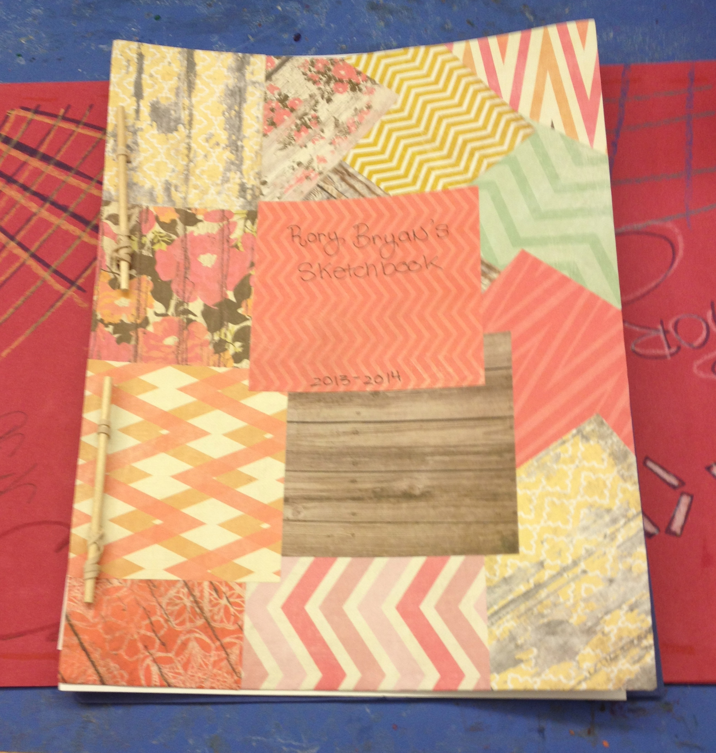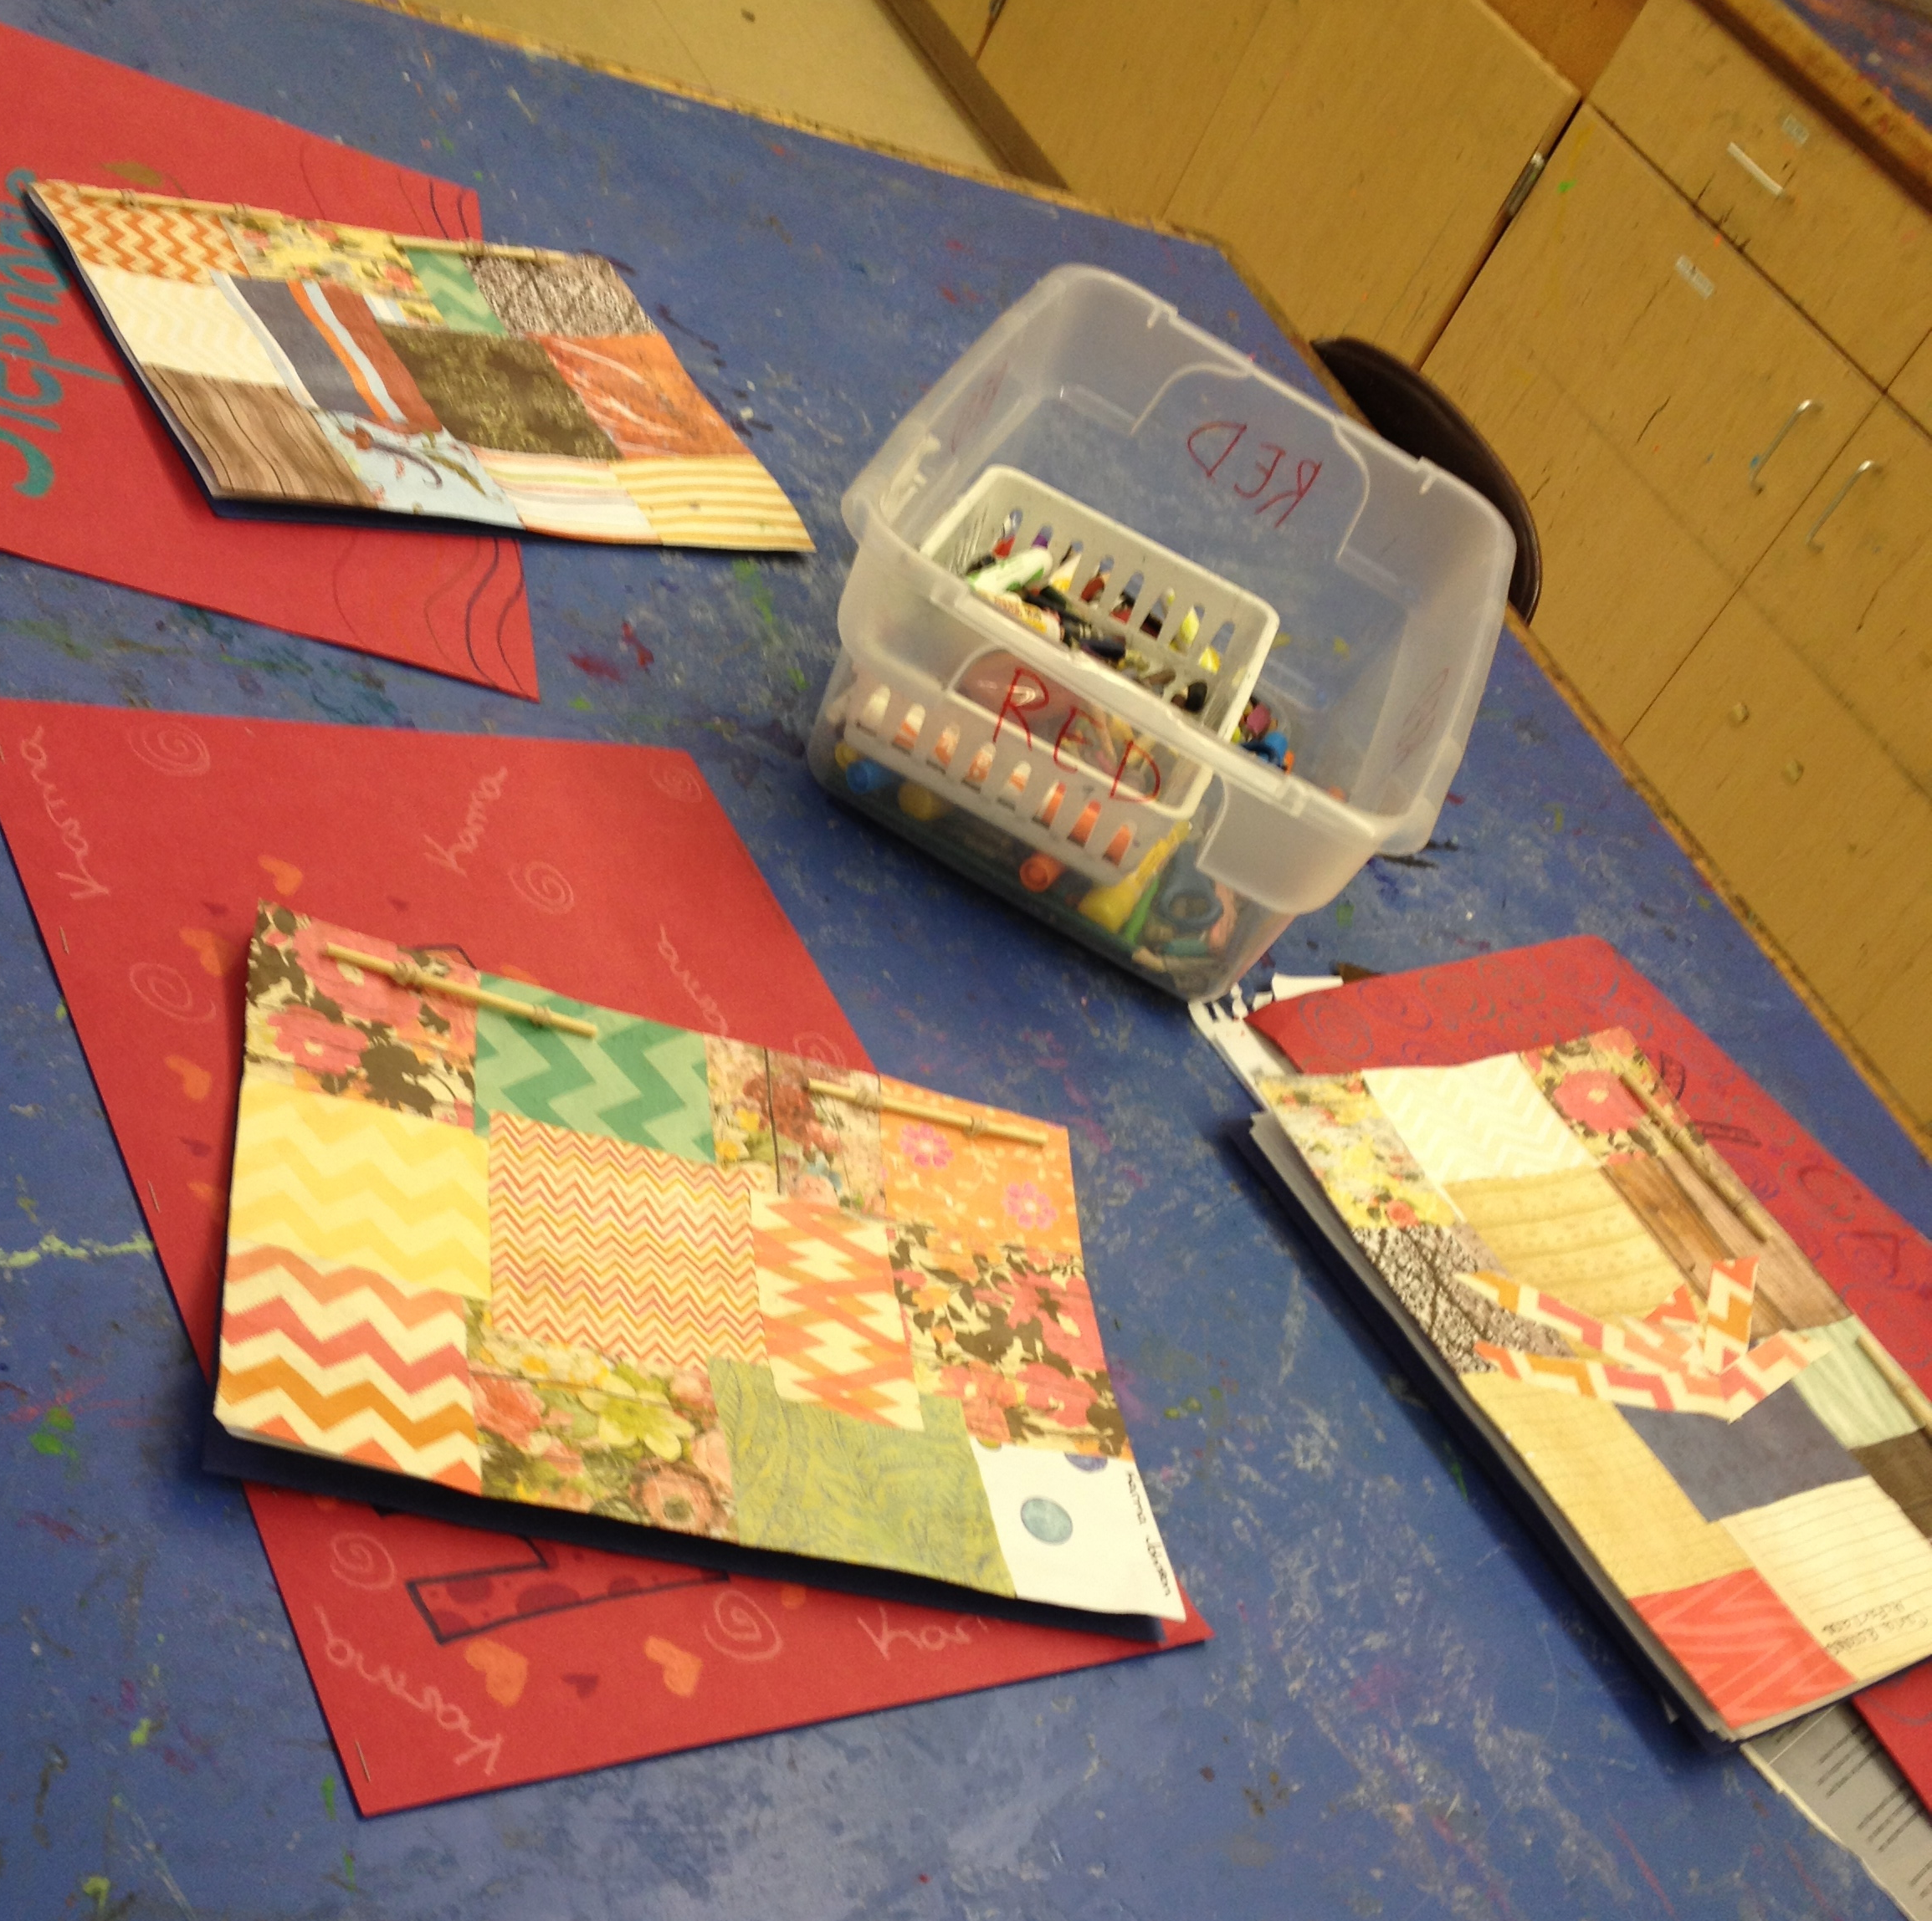
Midterm Assessment - Sketchbooks

TITLE OF LESSON: Sketchbooks (book making and composition)

GRADE LEVEL: 6th - 8th Grade

NUMBER OF CLASSES NEEDED: This assessment is an ongoing project that will last the entire second quarter. Students began creating their sketchbooks at the end of the first quarter and will be graded the last week of the second quarter.

LESSON OVERVIEW:

Students will design and construct a sketchbook using the method demonstrated in class. They will design a cover by collaging various decorative scrapbook paper together to make an interesting design, and also to add strength to the cover of their book. Once the cover is completed, students will assemble the book using techniques for a stick and elastic bound book. When the book is constructed, students will begin the sketching process whenever time is available to them. This means that if students finish work on a particular project early during any class period, they know to take out their sketchbook and work on their sketches and compositions. Students have been informed that they will have time to complete their sketchbooks during the time allotted for midterm assessments. They have also been informed that they will be graded not on the number of sketches present in their book, but by the quality and effort put forth. I am looking to see if the drawings are complete, if they have used concepts learned and if they have progressed from the beginning of their sketchbook to the end.

DESIRED UNDERSTANDINGS:

- Composition: In visual arts, the combination and arrangement of shape, form, color, line, texture, and space so that they seem satisfactory to the artist.

- Collage: A technique first used by Cubists such as Picasso and Braque to build two-dimensional images from fragments of printed paper and cloth incorporated into painting.

- Elements and Principles of visual arts: Elements are generally considered to be line, color, shape or form, texture, space, and value; principles are generally considered to be unity, variety, harmony, balance, rhythm, and emphasis.

- Foreground, middle ground, background: Layers of implied space or planes in the picture space of a two-dimensional work. The foreground is closest to the viewer, then the middle ground, and, most distant, the background.

- Representational Art: Art that seeks to portray things seen in the visible world; sometimes called figurative art.

ESSENTIAL QUESTIONS:

What do I want to be able to draw better? What is something I want to work on and practice for the remainder of the time in Art?

How can I show that I understand the concepts (elements and principles) learned within other projects throughout this year and years prior within my sketchbook?

VISUAL ARTS CURRICULUM FRAMEWORKS:

1.5 Expand the repertoire of 2D and 3D art processes, techniques, and materials with a focus on the range of effects possible within each medium, such as: 2D – transparent and opaque media, wet, dry, stippled, blended, wash effects; relief printmaking effects; 3D – mobile and stabile forms, carved, molded, and constructed forms (The book itself)

1.7 Maintain the workspace, materials, and tools responsibly and safely

1.9 Demonstrate the ability to create 2D and 3D works that show knowledge of unique characteristics of particular media, materials, and tools

1.10 Use electronic technology for reference and for creating original work

2.1 For color, explore and experiment with the use of color in dry and wet media
Identify primary and secondary colors and gradations of black, white and gray in the environment and artwork

2.8 For line, use and be able to identify various types of line, for example in contour drawings, calligraphy, freehand studies from observation, memory, and imagination, and schematic studies

2.11 For space and composition, create unified 2D and 3D compositions that demonstrate an understanding of balance, repetition, rhythm, scale, proportion, unity, harmony, and emphasis. Create 2D compositions that give the illusion of 3D space and volume

3.4 Create 2D and 3D representational artwork from direct observation in order to develop skills of perception, discrimination, physical coordination, and memory of detail

4.4 Produce work that shows an understanding of the concept of craftsmanship

4.8 Create and prepare artwork for group or individual public exhibitions

5.6 Demonstrate the ability to describe the kinds of imagery used to represent subject matter and ideas, for example, literal representation, simplification, abstraction, or symbolism

KEY KNOWLEDGE STUDENTS WILL GAIN FROM THIS LESSON:

- Cognitive: Students will learn the key to constructing a functioning and bound book on their own.

- Behavioral: Students will be sharing materials used for this lesson. If the students want to use well taken care of tools, paper and mediums, they will have to act responsibly when using them themselves.

- Affective: Students will have a chance to express what kind of artist they are within the drawings they choose to create. The content within the sketchbook is completely up to them, I am simply looking to see if they follow instructions and create completed and well thought out work that demonstrates the knowledge they have gained throughout their time in the art room.

EVIDENCE OF UNDERSTANDING AND LEARNING:

- Students will create a self-made sketchbook with complete drawings within. These drawings should show individual interests through both content and style.

- Students will successfully use the Elements and Principles of Design introduced from the list of line, shape, form, texture, pattern, etc., throughout the contents of their sketchbook.
- Students will have a chance to reflect on each other’s work once the sketchbooks are completed, as they will be viewed within the student exhibition. Students work as a team at their tables and have the chance to explain their work and choices to that team throughout the drawing process.

LESSON OUTLINE:

- Class 1
  - Demonstration on Bookmaking
    - Students will watch a demonstration on the creation of their sketchbook, step by step.
    - Students will also be handed a step by step instructional handout to aid in the process.
  - Explanation of Rubric and Grading Procedure
    - Students will have a chance to ask questions based on content and grading of their sketchbooks.
  - Students will begin constructing the covers of their sketchbooks
- Classes 2 and 3
  - Students will finish construction of their sketchbooks using the handout as a guide.
  - If some students finish early, they will use the remaining time to begin work on their drawings.
    - Students may use pictures and drawing books as guides for their drawings, but they are not allowed to copy.
Students will continue work on their sketchbooks when time allows for the remainder of their time in art. If they finish work on a particular project early, they will be instructed to take out and work on their sketchbooks. They will be given full class periods to complete their work during Midterm time in January.

SPECIAL NEEDS CONSIDERATIONS:

Students who need help creating their sketchbooks will be given extra time with me to construct the binding and whatever else they may need help with. Tools that are better suited for specific students will also be on hand for added assistance.

ELL ESL CONSIDERATIONS:

The handout created for directional purposes when constructing their sketchbook include pictures for each step. This will further explain the step by step instructions in a more universal way.
MATERIALS LIST:

- Pencils
- Scissors
- Markers/Colored Pencils/Crayons
- Drawing paper
- Construction Paper
- Elastics
- Small 4” sticks
- Glue
- Hole punch
- Instructional Handouts
- Computer and projector (for PowerPoint presentation)

ASSESSMENT RUBRIC:

Criteria of Assessment | 4  Exceptional | 3  Meets Criterion | 2  Limited Proficiency | 1  Does Not Meet Criterion
Sketchbooks (Concept and Execution) | Student created an exceptional Sketchbook that was visually and conceptually gripping. The sketchbook used the techniques learned in the demonstration to its advantage to help create a structurally sound book. The sketchbook showed clear imagination and knowledge of technique and understanding of concepts learnt through complete, finished and innovative drawings. | Students created a strong Sketchbook that was visually and conceptually appealing. The techniques learned in the demonstration were properly used showing an understanding of bookmaking. The sketchbook showed creativity and understanding of concepts through complete drawings. | Students created a Sketchbook that did not clearly show proper use and understanding of bookmaking. The sketchbook shows little creativity, unclear if concepts are understood. | Student struggles to create a Sketchbook. Little or no use of the techniques previously learned class. Does not show an understanding of either book making or the elements and principles of art.

